***Brief***: 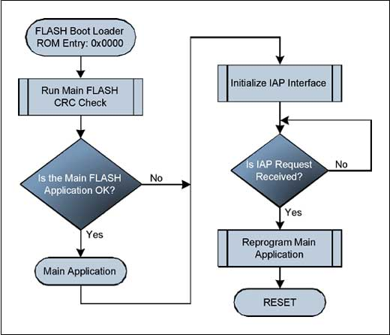 Produce a report explaining how sequence, selection and iteration are used when writing programs. Give examples of each and reference your images.

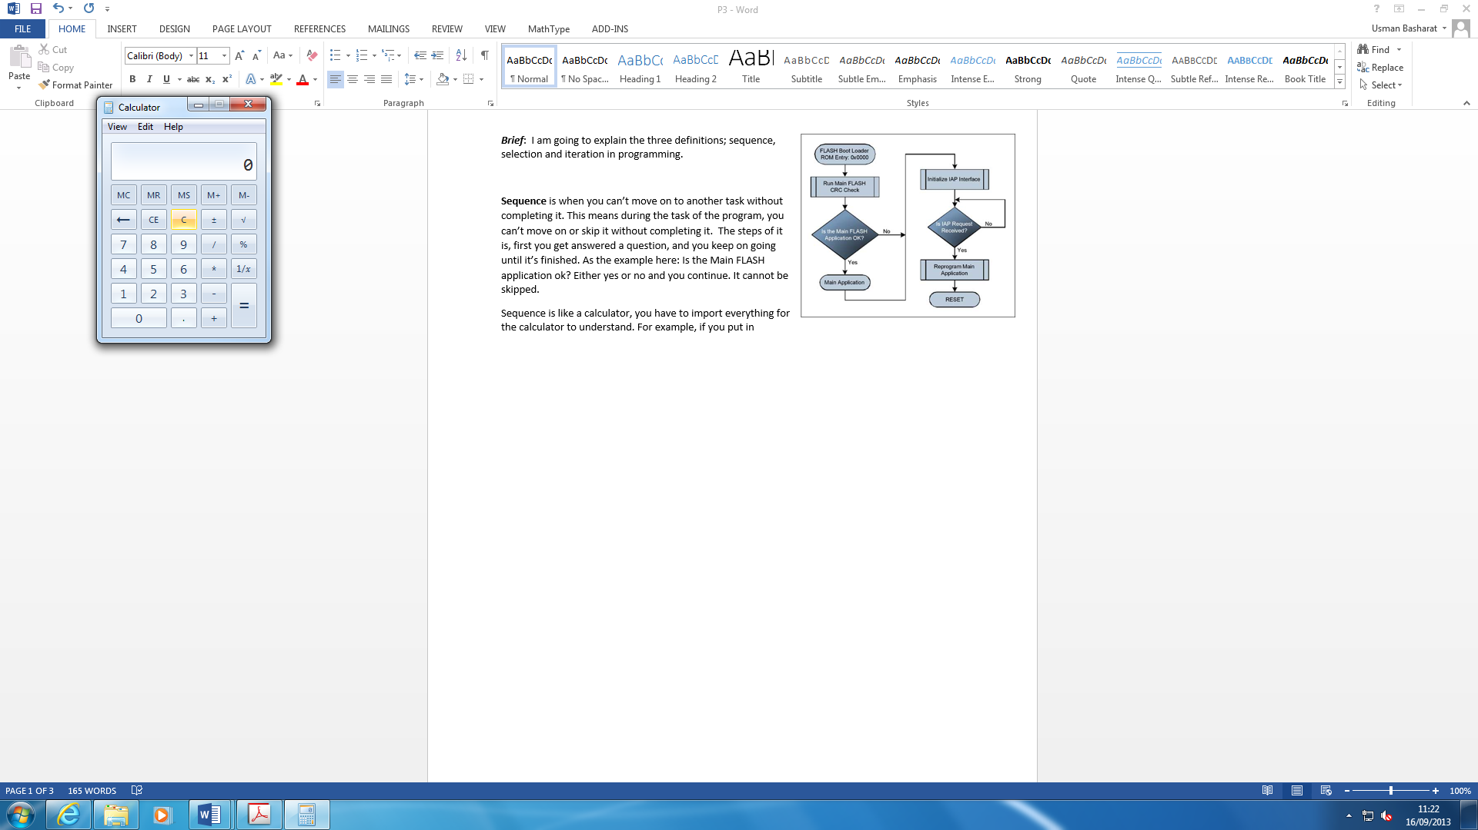**Sequence** is when you can’t move on to another task without completing it. This means during the task of the program, you can’t move on or skip it without completing it. The steps of it is, first you get answered a question, and you keep on going until it’s finished. As the example here: Is the Main FLASH application ok? Either yes or no and you continue. It cannot be skipped.

[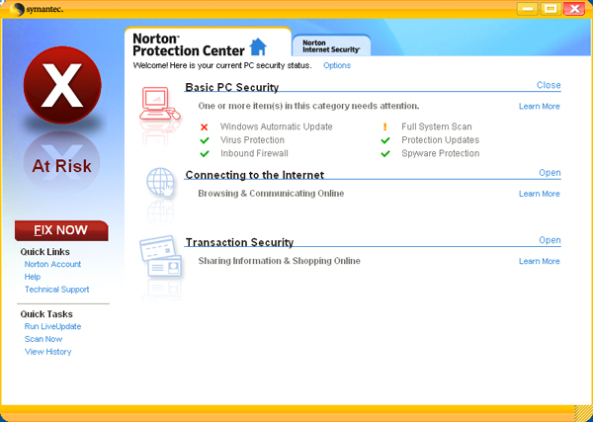](http://www.google.co.uk/url?sa=i&rct=j&q=&esrc=s&frm=1&source=images&cd=&cad=rja&docid=AuJnCuubEgaddM&tbnid=LZgRvYlPJXuREM:&ved=0CAUQjRw&url=http://www.pcmag.com/slideshow_viewer/0,3253,l=190254&a=190254&po=1,00.asp&ei=Vdw2Us7MKo3X7AbgrYHYAg&bvm=bv.52164340,d.ZGU&psig=AFQjCNGRCr0k4yrNor4VPzauu2kp9hZttQ&ust=1379413449098744)Sequence is like a calculator, you have to import everything for the calculator to understand. For example if you enter a wrong key, the calculator won’t sensor it. The right key needs to be done in order to get your result. In relation to programming, if you enter the wrong eye it won’t let you proceed. The advantage is that it requires small amount of memory, and it has specific commands without any errors. The disadvantage is that it needs to be fully complete.

[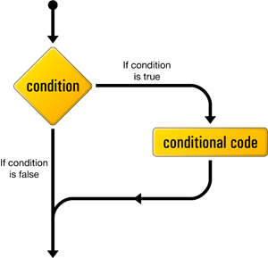](http://www.google.co.uk/url?sa=i&rct=j&q=&esrc=s&frm=1&source=images&cd=&cad=rja&docid=r9Gapsyk0XwprM&tbnid=TSmS1BEKS7KERM:&ved=0CAUQjRw&url=http://c4learn.com/javaprogramming/if-statement-in-java-programming-conditional-selection/&ei=fN02UoPmEKuV7AbltYDoDA&bvm=bv.52164340,d.ZGU&psig=AFQjCNH6uFTtcN6hFZWi-BvmX_328BjA4g&ust=1379413753419187)

**Selection** means options. In programming, you can choose which one you want to do. This is a decision made on some criterion. In programming, word, ‘if’ is used to give the user the option.

This picture shows that in programming, it gives more than one option to choose.

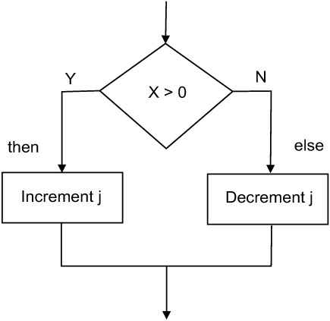

[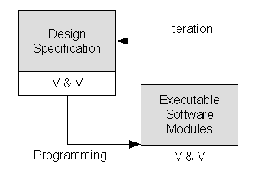](http://www.google.co.uk/url?sa=i&rct=j&q=&esrc=s&frm=1&source=images&cd=&cad=rja&docid=QFKbmtn3SeFK3M&tbnid=2LorFC3SfDGjTM:&ved=0CAUQjRw&url=http://courses.cs.vt.edu/csonline/SE/Lessons/Waterfall/&ei=5N02Ur6mL8T17AaT_4HYAQ&bvm=bv.52164340,d.ZGU&psig=AFQjCNF40_7w19Z_GCWl4iN3rGZLeA4ySQ&ust=1379413849609509)

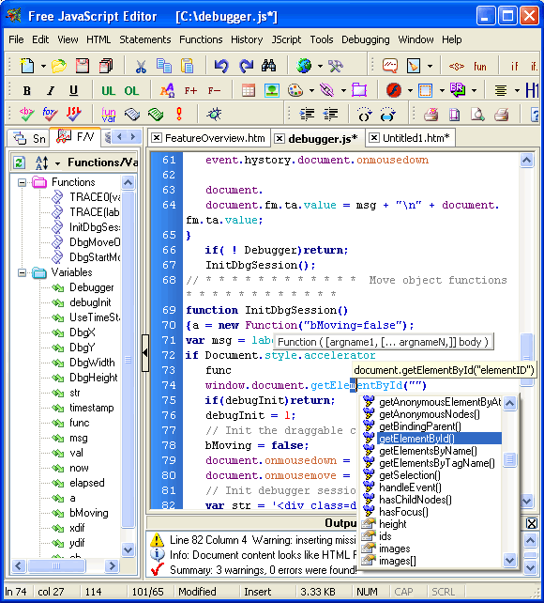

**Iteration** is where the cycle of operation is repeated. An example of an iteration can be JavaScript. They perform specific tasks and solve programmes using iteration. Many programmes use iteration to process tasks. For example, a website could use iteration that has HTML code to refresh the page without the user pressing the refresh button.

|  |  |
| --- | --- |
| Reference | Document/Image |
| <http://book.javanb.com/object-oriented-programming-from-problem-solving-to-java/images/fig145_01_0.jpg> | Image |
| <http://www.maximintegrated.com/images/appnotes/3576/3576Fig05.jpg> | Image |
| [PDF file](Unit%206%20Software%20design%20and%20development.pdf)- BTEC LEVEL 3 ICT BOOK | Book |
| <http://courses.cs.vt.edu/csonline/SE/Lessons/Waterfall/> | Image |
| <http://c4learn.com/javaprogramming/if-statement-in-java-programming-conditional-selection/> | Image |
| <http://www.yaldex.com/FSimages/freejseditor.gif> | Image |